**Name -** Vishal Kompella

**Title –** Game Sales Tableau Dashboard.

**Section 1: The Dashboard**

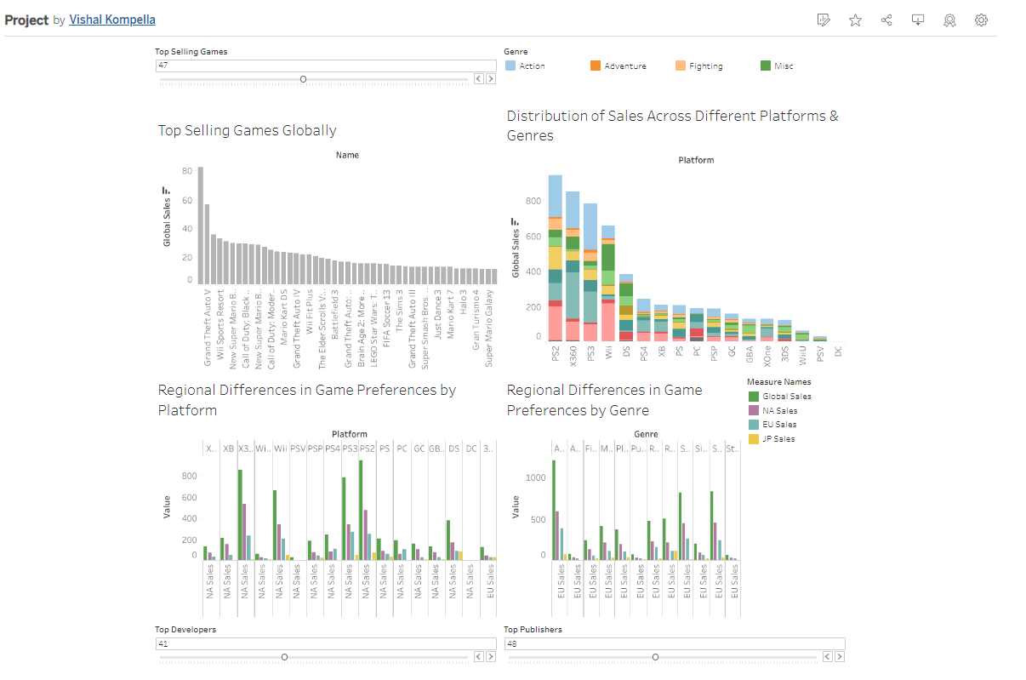

This dashboard is used for analyzing and predicting video game sales and ratings. It includes information on video games released between 1980 and 2016, such as the name, platform, year of release, genre, publisher, sales data for North America, Europe, Japan, and the rest of the world, and critic and user ratings. This can be useful for anyone interested in the video game industry, including game developers, market analysts, and gamers themselves. By analyzing this data, they can gain insights into the trends and patterns that drive the success of video games, and make more informed decisions about game development, marketing, and purchasing.

**Section 2: The Dataset**

Data on video game sales, user and critic reviews, and associated variables are all included in the "Video Game Sales with Ratings" dataset. The dataset's 16 columns offer useful information about numerous facets of the gaming industry.

Detailed sales data for North America, Europe, Japan, and other locations are included in this dataset, along with information on game titles, platforms, release dates, genres, and publishers. Additionally, it provides Metacritic's aggregate critic and user ratings along with the total number of critics and users that contributed to those ratings. The dataset also contains information about the game's developers and ESRB scores.

We may learn more about the trends, preferences, and connections between different elements in the game industry by examining this dataset, including sales, ratings, and regional variations. Game designers, publishers, market researchers, players, and academic organizations interested in studying the gaming industry may find this information useful.

These are the columns in this dataset:

1. Name: Name of the video game (Categorical)
2. Platform: Console or platform the game is available on (Categorical)
3. Year_of_Release: Year the game was released (Ordinal)
4. Genre: Genre of the game (Categorical)
5. Publisher: Publisher of the game (Categorical)
6. NA_Sales: Sales in North America (in millions) (Ratio)
7. EU_Sales: Sales in Europe (in millions) (Ratio)
8. JP_Sales: Sales in Japan (in millions) (Ratio)
9. Other_Sales: Sales in other regions (in millions) (Ratio)
10. Global_Sales: Total global sales (in millions) (Ratio)
11. Critic_Score: Aggregate score compiled by Metacritic (Ratio)
12. Critic_Count: Number of critics used in coming up with the Critic_score (Ratio)
13. User_Score: Score by Metacritic's subscribers (Ratio)
14. User_Count: Number of users who gave the User_Score (Ratio)
15. Developer: Party responsible for creating the game (Categorical)
16. Rating: The ESRB rating (Categorical)

**Pre-processing:**

**Removing Null Values**

A null value is assigned to a blank field that represents undefined values.

The data are displayed along a continuous axis when you drag a measure or continuous date to the screen. Tableau is unable to show null values, zeroes, or negative values on a logarithmic axis. Tableau indicates that unknown values exist in the lower-right corner of the image when specific values are present.

By filtering the data, you can remove the null values from the view. Null values are removed from calculations made in the view when you filter the data, making the data suitable for data visualization.

**Section 3: Dashboard Users**

A dashboard developed with this dataset could be used by:

**1. Game Developers:** To design better-targeted games that satisfy consumer demand and preferences, game creators must examine trends and sales data of various games, platforms, and genres.

**2. Game publishers:** Investors can concentrate on the most lucrative projects and platforms when making future investment decisions by understanding customer preferences and market trends.

**3. Market analysts:** To research the gaming sector, its expansion, and its effects on the economy, offering insightful information that can guide investment decisions and economic projections.

**4. Gamers:** To learn about the most well-liked games, trends, and ratings so they may choose games that suit their tastes and offer high-caliber pleasure.

**5. Educational institutions:** To research the gaming industry and design curricula in order to better comprehend its dynamics and to prepare students for careers in the sector.

**6. Advertising agencies:** To find popular games and platforms for targeted advertising campaigns and collaborations with game publishers or creators, optimizing their advertising reach.

**Section 4: Questions**

1. What are the top-selling games globally?
2. What is the distribution of sales across different platforms and genres?
3. What are the trends in game sales over the years?
4. How do game sales compare over different regions?
5. Which are the most popular game developers and publishers?
6. How does the ESRB rating influence game sales?
7. Are there any regional differences in game preferences (genre, platform, etc.)?
8. How do user and critic scores correlate with each other?
9. What are the most common ESRB ratings for games in the dataset?
10. How does the trend look in the gaming industry in terms of genre popularity over time?

**Section 5: Plots**

**Plot 1:**

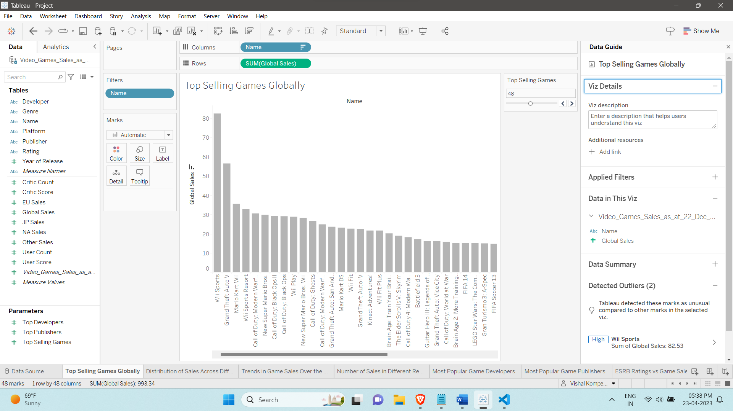

This plot shows the global top selling games. Here we use a bar chart and we use a filter to filter through the Top – N selling games globally. This particular visualization addresses question 1 “What are the top-selling games globally?”

**Plot 2:**

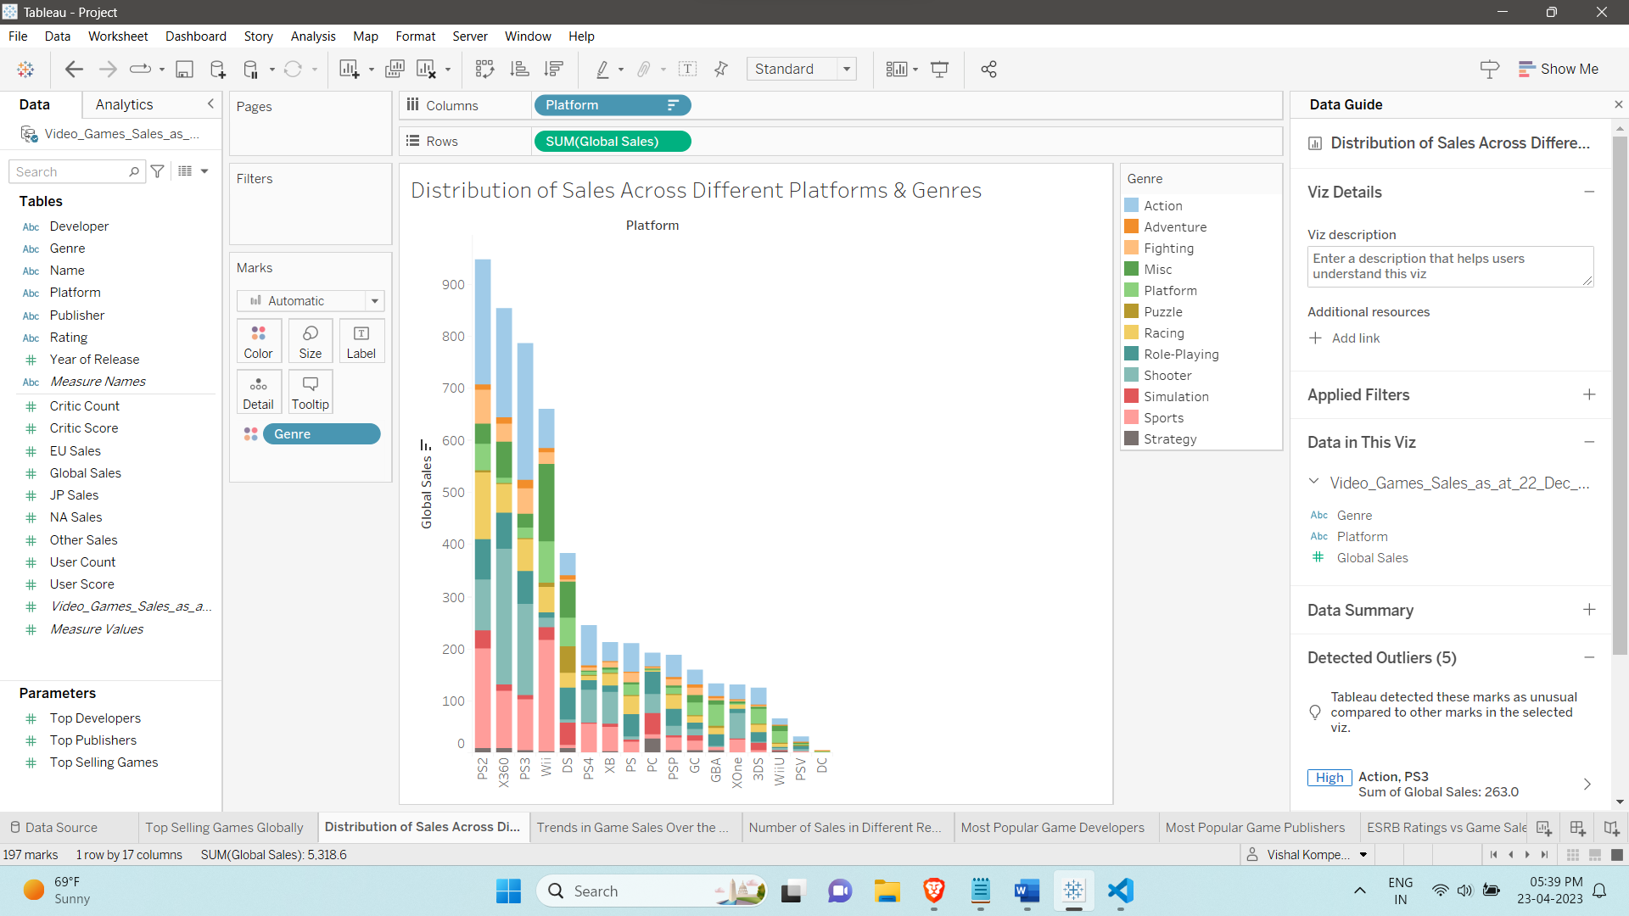

This plot shows the global distribution of sales across different platforms & genres using a stacked bar chart. The different colors represent different genres like Action, Adventure etc. and each platform like PS2, DS have games from those different genres. This chart addresses question 2 “What is the distribution of sales across different platforms and genres?”.

**Plot 3:**

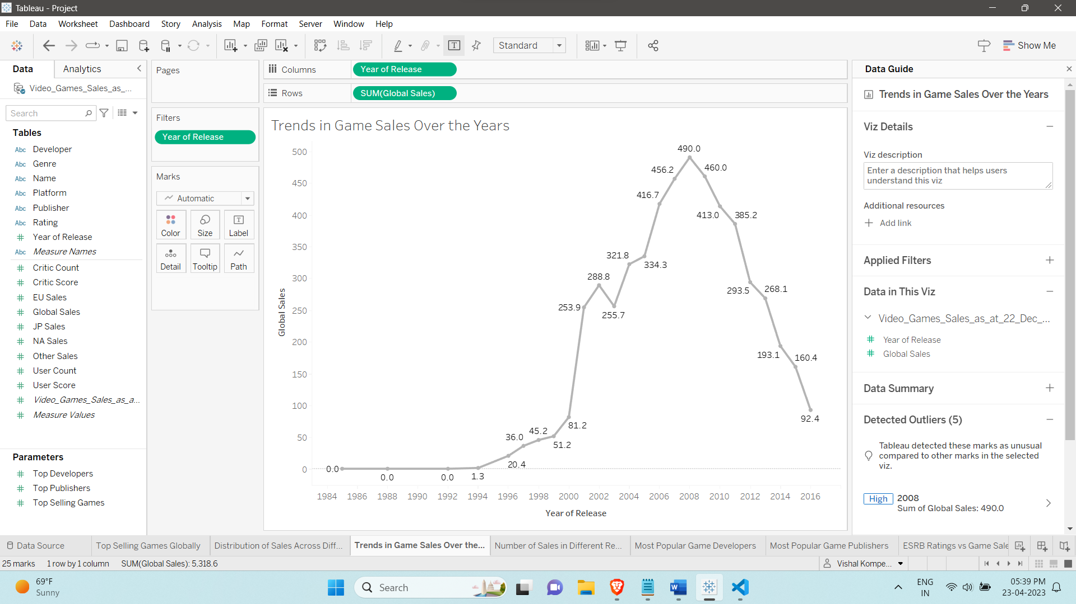

This plot shows the trends in game sales over the years 1980 - 2020 using a line chart. A change in trend can be best visualized using this line chart and we can see which year had the highest sales and which had the lowest. It addresses question 3 “What are the trends in game sales over the years?”

**Plot 4:**

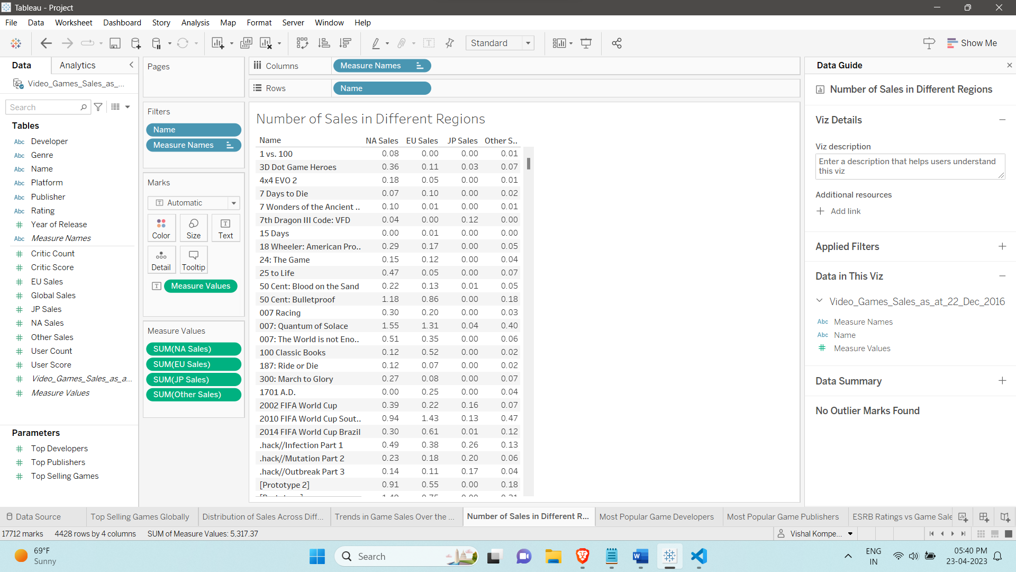

This plot shows how the number of sales are distributed across the different regions of the world like NA (North America), EU (Europe), JP (Japan) and other regions. We use a text table here as it is easy to visualize and compare the sales from all these regions. This table addresses the question 4 “How do game sales compare over different regions?”

**Plot 5:**

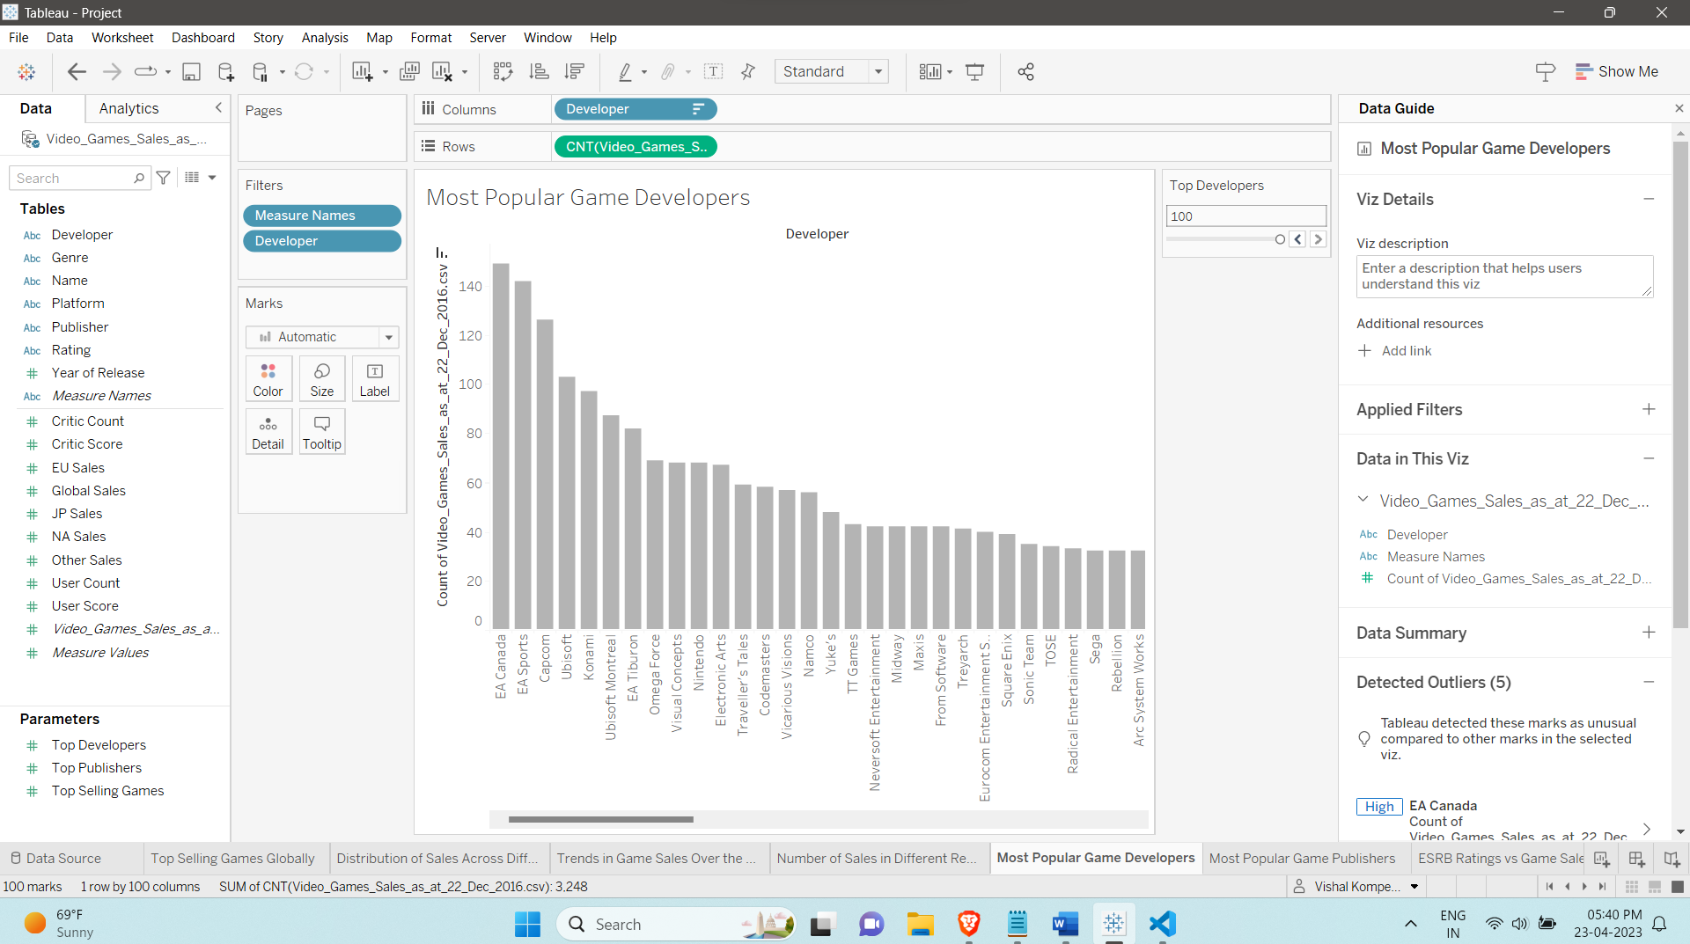

This plot shows the most popular game developers using a bar chart. Using a slider filter, we can filter through the Top-N most popular game developers. It addresses the first part of the question 5 “Which are the most popular game developers and publishers?” (This question is divided into 2 plots “most popular game developers” and “most popular game publishers”)

**Plot 6:**

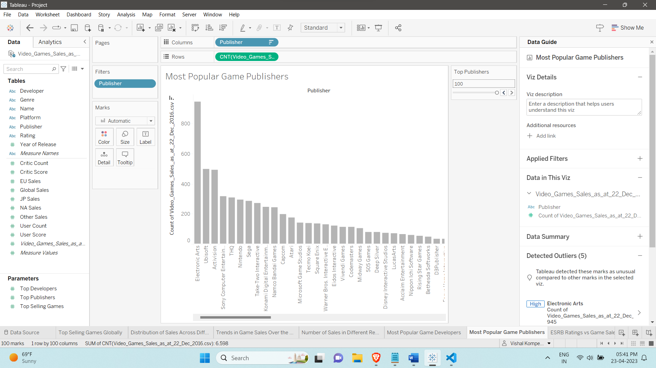

Similar to the previous plot, this visualization shows the most popular game publishers using a bar chart. Using a slider like above we can filter through the Top-N popular game publishers. It addresses the second part of the question 5 “Which are the most popular game developers and publishers?” (This question is divided into 2 plots “most popular game developers” and “most popular game publishers”)

**Plot 7:**

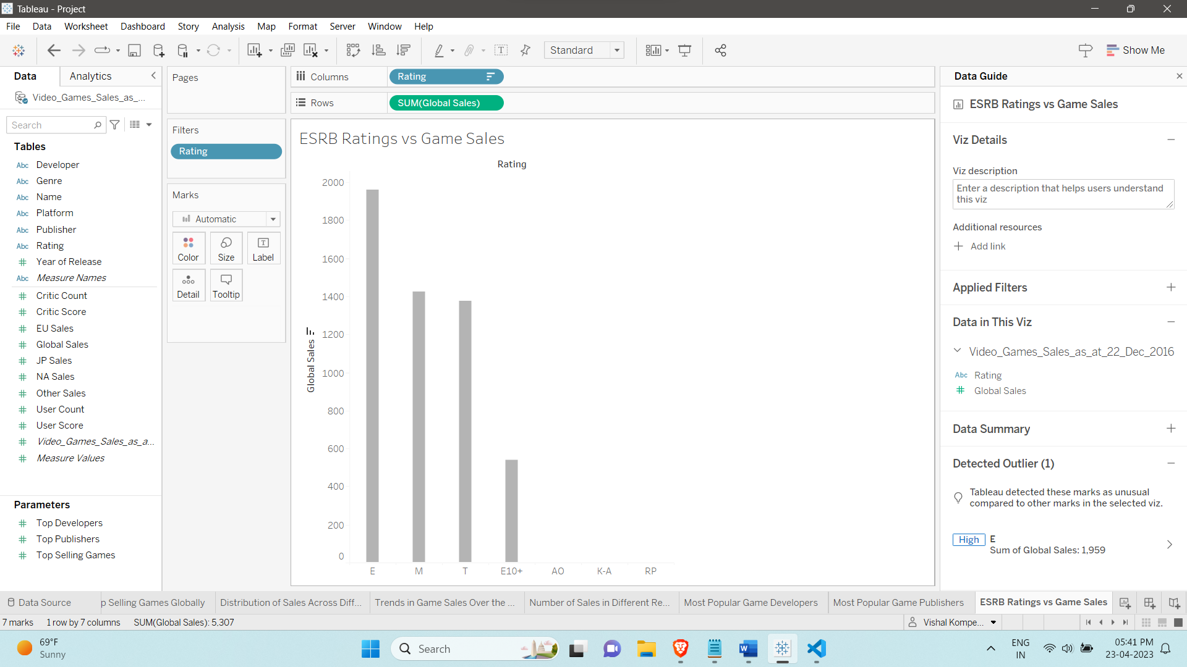

This plot is a simple bar chart that shows the ESRB ratings vs Game Sales. This shows games with a particular rating have more sales than the others. It addresses the question 6 “How does the ESRB rating influence game sales?”

**Plot 8:**

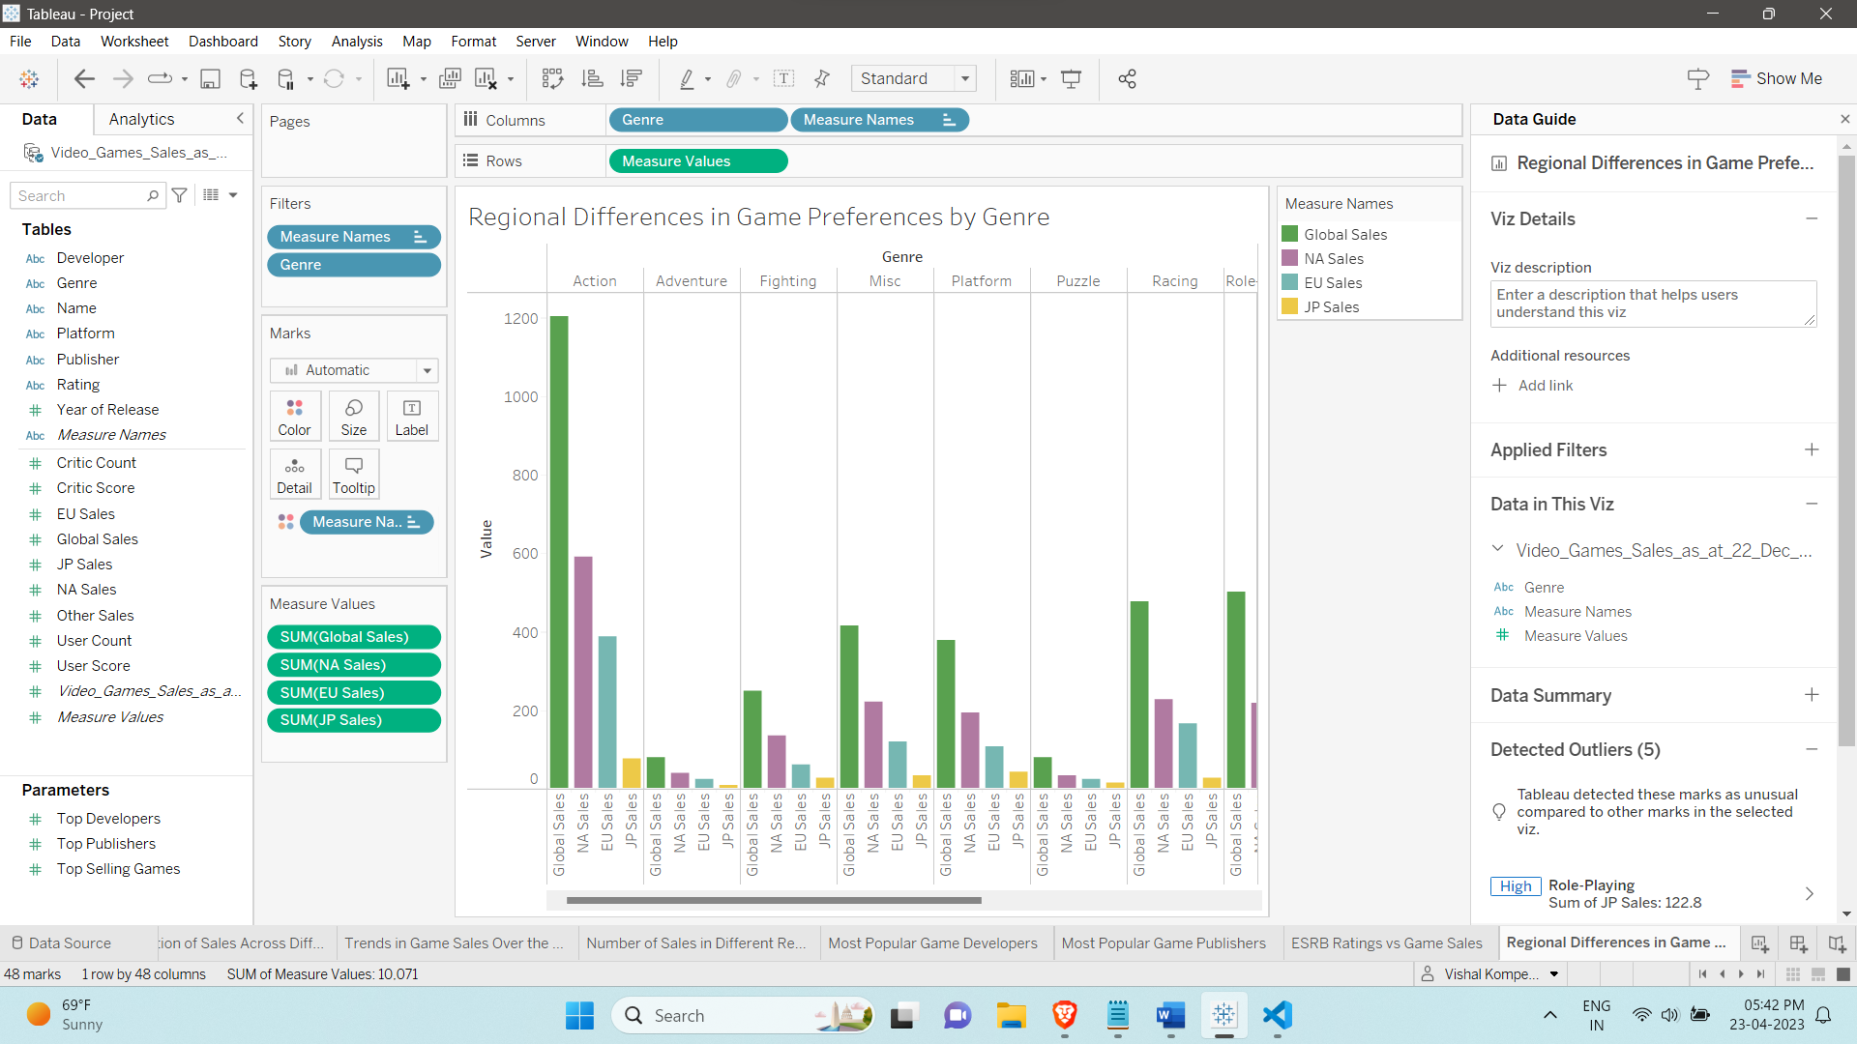

This plot shows the regional differences in game preferences by genre using a multi-series bar chart. The various colors are used to differentiate between the different regions. This chart addresses the first part of the question 7 “Are there any regional differences in game preferences (genre, platform, etc.)?” (This question is divided into 2 plots “regional differences in game preferences by genre” and “regional differences in game preferences by platform”)

**Plot 9:**

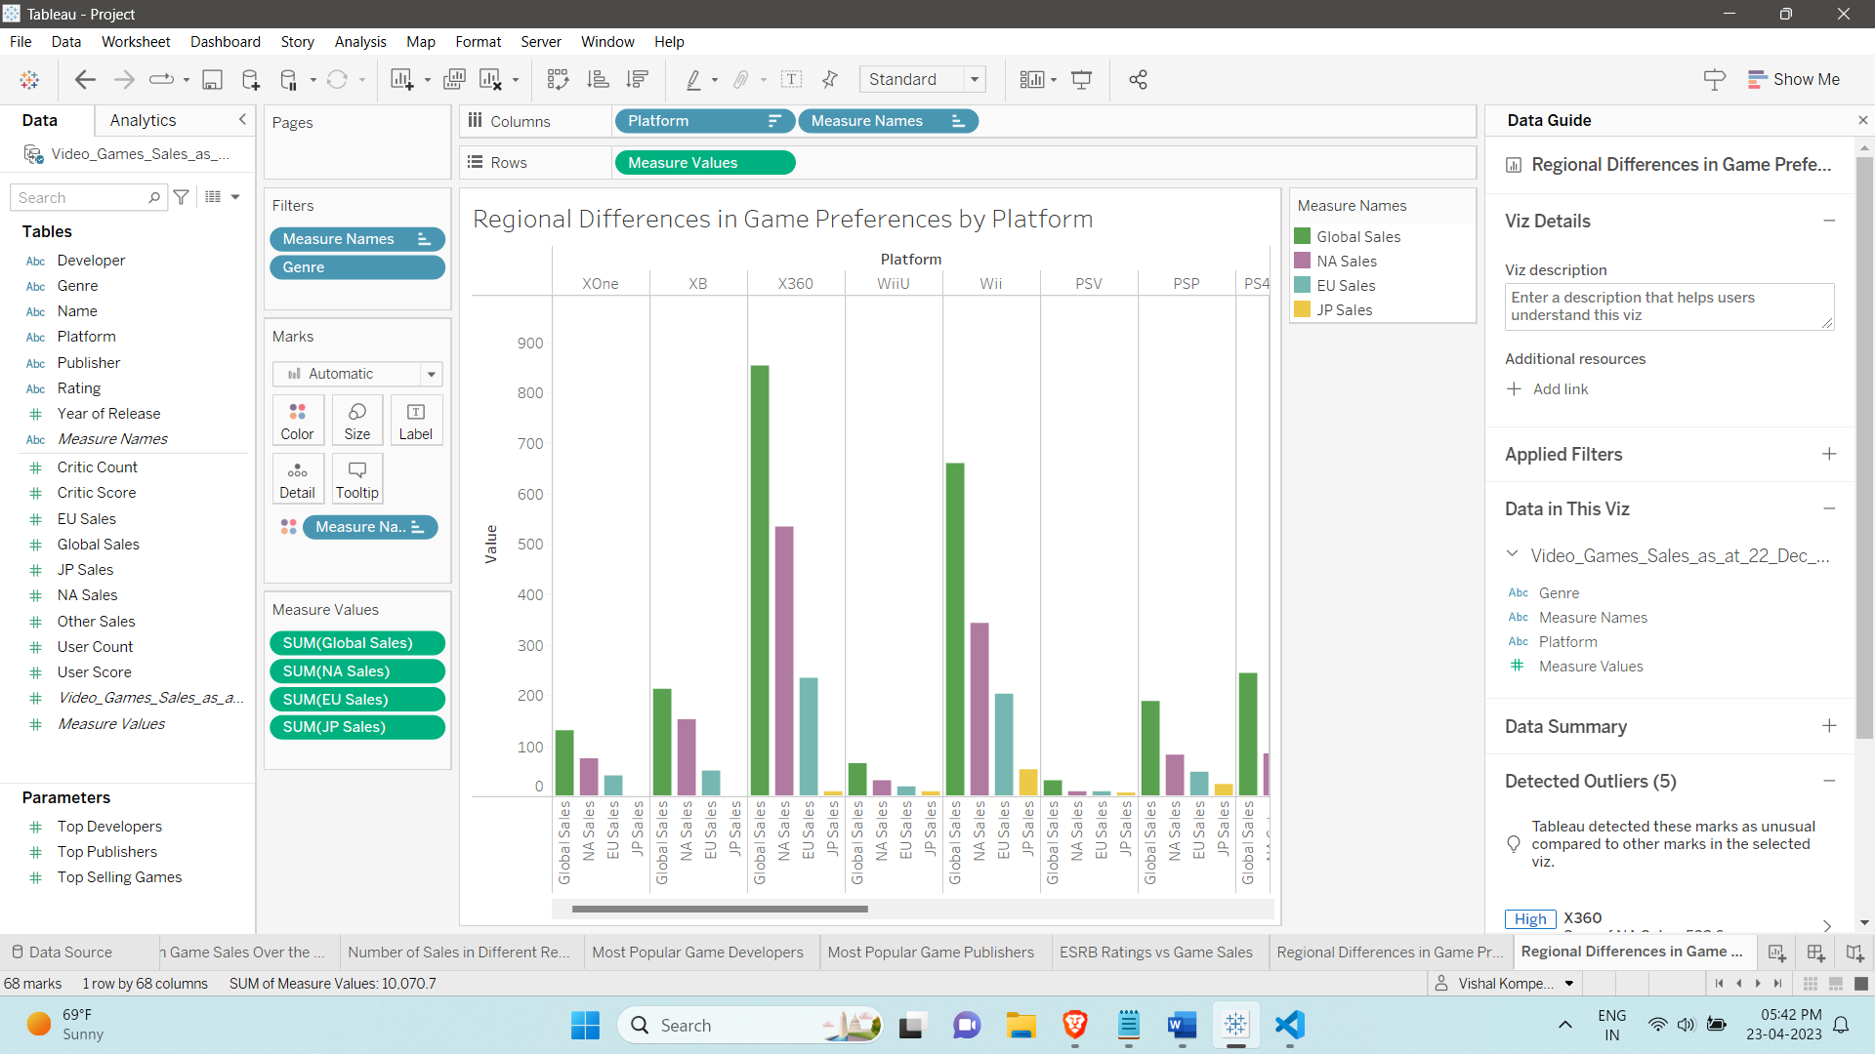

This plot shows the regional differences in game preferences by platform using a multi-series bar chart. The various colors indicate sales from different regions. It addresses the second part of the question 7 “Are there any regional differences in game preferences (genre, platform, etc.)?” (This question is divided into 2 plots “regional differences in game preferences by genre” and “regional differences in game preferences by platform”)

**Plot 10:**

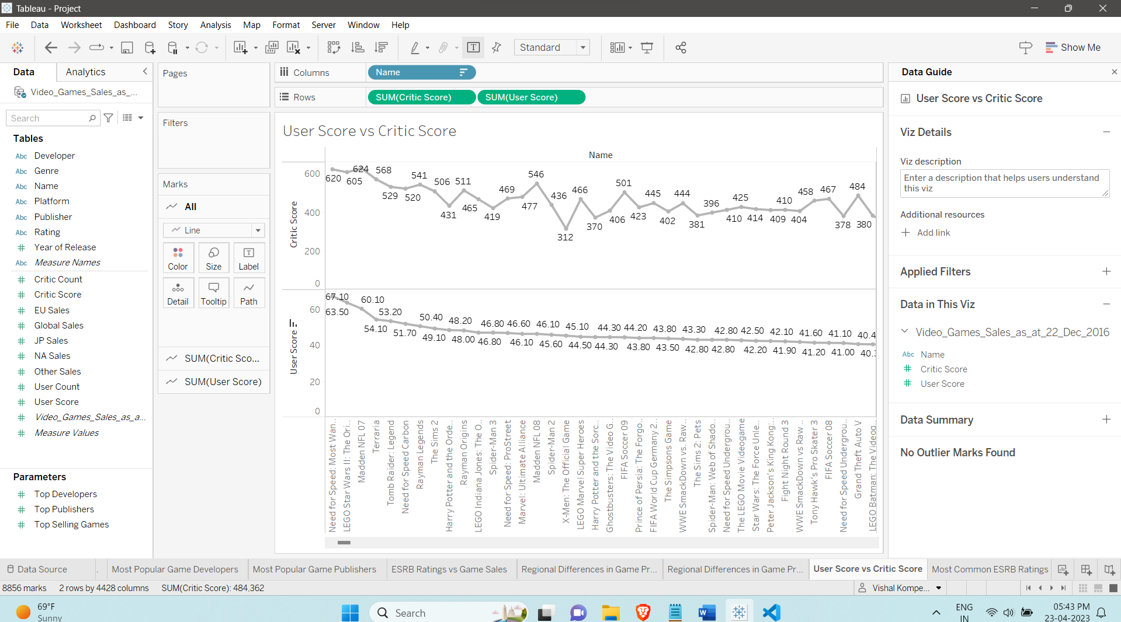

This plot shows the user score vs critic score using line charts. It also how user score trends compare to that of the critic score (For example we can notice a steady trend for user score which is not the case for critic score). This chart addresses the question 8 “How do user and critic scores correlate with each other?”

**Plot 11:**

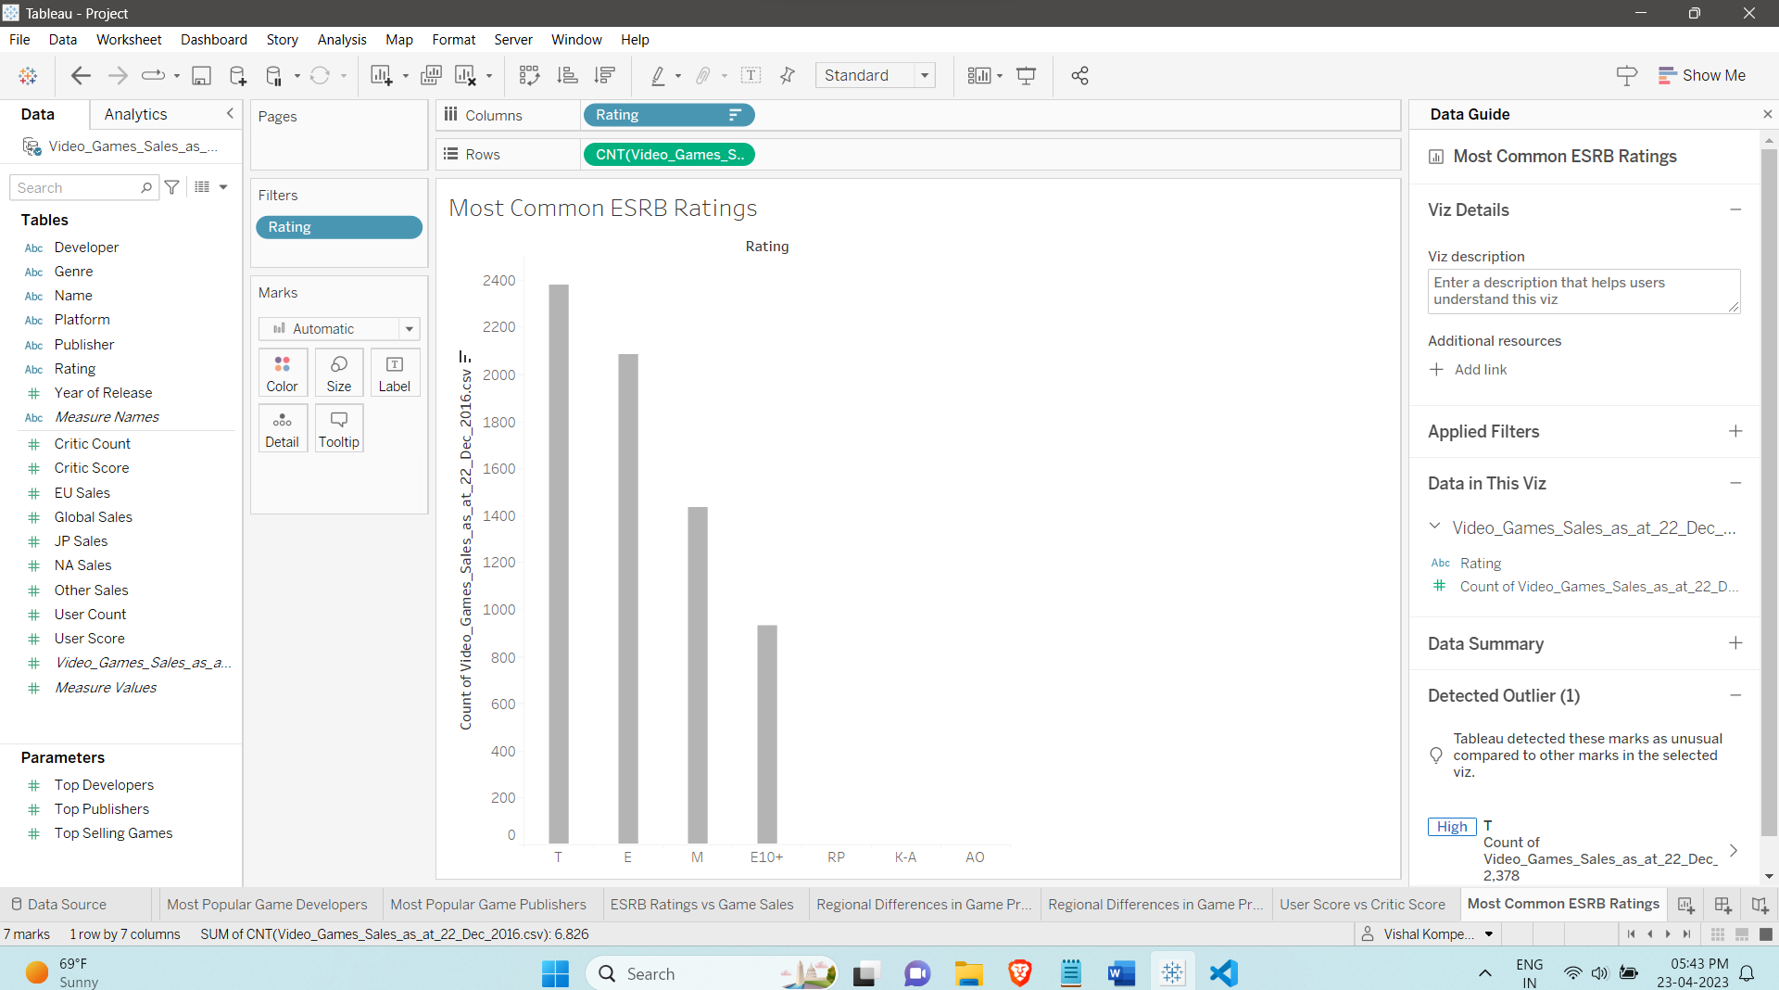

Similar to the plot 7, this visualization shows the most common ESRB ratings using a bar chart and it addresses the question 9 “What are the most common ESRB ratings for games in the dataset?”

**Plot 12:**

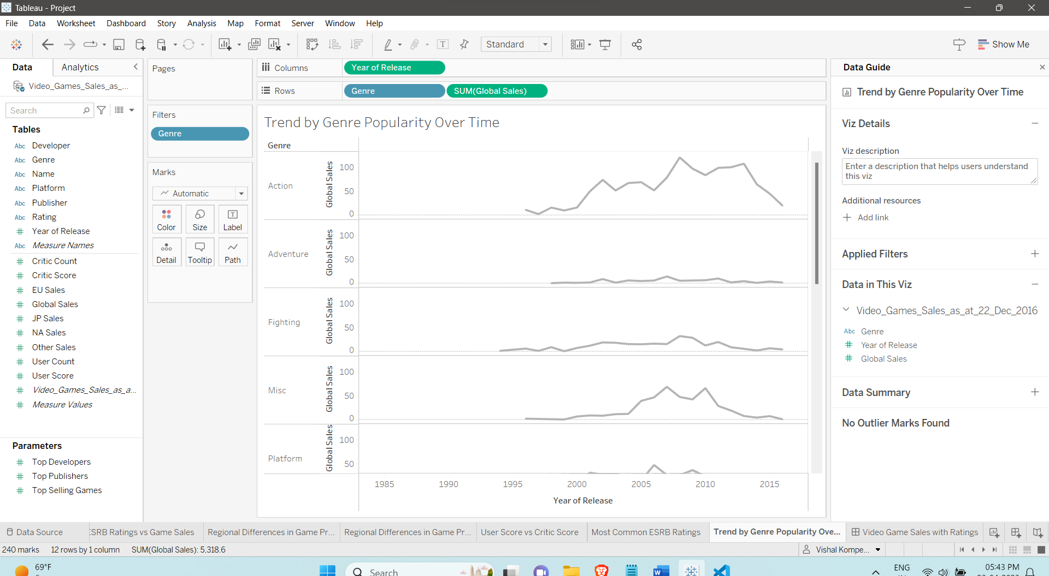

This plot shows the trend by genre popularity over time from 1980 - 2016 using line charts. We can thus compare the various genres against each other for each year and determine which genre is popular for that particular year. It addresses the question 10 “How does the trend look in the gaming industry in terms of genre popularity over time?”

**Section 6: Interactivity**

We can see from the aforementioned visualizations that Plots 1, 5, and 6 are interactive on the dashboard.

Plot 1:

The dashboard in this visualization can be manipulated using a slider filter. We can choose the Top 'N' Selling Games Worldwide using this filter.

Plot 5:

Here, the dashboard is manipulated using a slider filter. This allows us to filter the Most 'N' Popular Game Developers.

Plot 6:

Here, the user interacts with the dashboard once again using a slider. The Most 'N' Popular Game Publishers can be filtered using this.

**Published Dashboard Link**

<https://public.tableau.com/shared/FW5CS7YSR?:display_count=n&:origin=viz_share_link>